INNOVA JUNIOR COLLEGE
JC 2 PRELIMINARY EXAMINATION 2
in preparation for General Certificate of Education Advanced Level
Higher 1

CANDIDATE
NAME

CLASS INDEX NUMBER

CHEMISTRY  Paper 2 Structured and Free Response Questions  Section A: Structured Questions  Candidates answer Section A on the Question Paper  Section B: Free Response Questions  Additional Materials: Writing Papers  Data Booklet | 8872/02  20 September 2010  2 hour

READ THESE INSTRUCTIONS FIRST

Write your index number, name and civics group on all the work you hand in.
Write in dark blue or black pen.
You may use pencil for any diagrams, graphs or rough working.
For Examiner’s Use
Section A
1 | 13
2 | 8
3 | 9
4 | 10
Total | 40

Do not use staples, paper clips, highlighters, glue or correction fluid.

Section A: Structured Questions (40m)
Answer all questions in the space provided.

Section B: Free Response Questions (40m)
Answer two questions on separate writing papers.

You are advised to show all working in calculations.
You are reminded of the need for good English and clear presentation in your answers.
You are reminded of the need for good handwriting.
Your final answers should be in 3 significant figures.

You may use a calculator.

The number of marks is given in brackets [ ]
at the end of each question or part question.

At the end of the examination, fasten all your work securely together.

This document consists of 16 printed pages.
 | Innova Junior College | [Turn over

Section A
Answer ALL questions in this section on the space provided.

1 | Iron(II) sulfate and ammonium sulfate combine to form the double salt iron(II) ammonium sulfate, FeSO₄.(NH₄)₂SO₄.xH₂O.  11.0 g of the double salt was dissolved in dilute sulfuric acid and made up to 250 cm³ mark in a standard flask. 25.0 cm³ of the solution required 28.00 cm³ of 0.02 mol dm⁻³ KMnO₄ for titration.
 | (a) | (i) | Write a balanced ionic equation for the reaction between Fe²⁺ and acidified MnO₄⁻.
 |  |  | …………………………………………………………………………………………....
 |  | (ii) | Calculate the number of moles of MnO₄⁻ used in the titration.
 |  | (iii) | Calculate the number of moles of Fe²⁺ in 250 cm³ solution.
 |  | (iv) | Calculate the M_{r} of the double salt.
 |  | (v) | Calculate the value of x.
 |  |  | [6]
 | (b) | Draw the Lewis structure of the NH₄⁺ and state its shape.
 |  | Shape of NH₄⁺ : …………………………………………………..
 |  | [2]
 | (c) | The reaction between zinc and copper(II) sulfate solution is exothermic and is represented by the following equation:  Zn(s) + CuSO₄(aq) ZnSO₄(aq) + Cu(s)
 |  | (i) | Apart from a temperature rise, state two observations which could be made from the above reaction.
…………………………………………………………………………………………....

…………………………………………………………………………………………....

…………………………………………………………………………………………....
 |  | (ii) | When excess zinc powder was added to a polystyrene cup containing 75.0 cm³ of aqueous copper(II) sulfate at 20.5 ºC, the temperature rose to 33.7 ºC. The copper metal formed was collected, washed, dried and found to weigh 0.42 g. Calculate the enthalpy change for this reaction in kJ per mole of copper formed.
 |  | [5]
 |  | [Total: 13 ]

2 | Acetic acid, CH₃COOH, also known as ethanoic acid, is an organic acid that gives vinegar its sour taste and pungent smell. It is a weak acid as it is only partially dissociated in an aqueous solution.
 | (a) | Write the K_{a} expression for ethanoic acid.
 |  | [1]
 | (b) | (i) | When a weak acid dissociates in aqueous solution, the concentration of H⁺ is given by the following expression.  [H⁺] =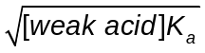  Given that the concentration of ethanoic acid is 0.720 mol dm⁻³ and its K_{a} is 1.8 x 10⁻⁵ mol dm⁻³. Calculate the concentration of H⁺ and pH of ethanoic acid.
 |  | (ii) | Suggest and explain the choice of an indicator for the titration of ethanoic acid and aqueous NaOH.
…………………………………………………………………………………………....

…………………………………………………………………………………………....

…………………………………………………………………………………………....
 |  |  | [4]
 | (c) | It is known that the relative molecular mass of ethanoic acid is 60. However, when ethanoic acid is dissolved in benzene, it is found that the relative molecular mass of the acid is 120. Explain this phenomenon using a clearly labelled diagram.
……..…………………………………………………………………………………………....

…………………………………………………………………………………………..............

…………………………………………………………………………………………..............

Labelled diagram:

 |  | [3]
 |  |  | [Total: 8]
3 | Succinic acid, C₄H₆O₄ is a colourless crystalline solid with a melting point of 185 –187 ºC. It occurs naturally in plant and animal tissues.
 | (a) | The scheme below shows how succinic acid, can be prepared from ethene.
 | 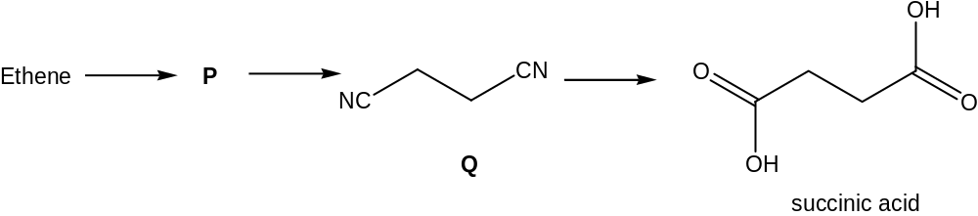
 |  | (i) | Suggest the structure of P.
 |  | (ii) | Suggest how P can be prepared from ethene and name the type of reaction involved.
Reagent(s) : …………………………………………………….…………………

Conditions : …………………………………………………….…………………

Type of reaction : …………………………………………………….……………
 |  | (iii) | Suggest how succinic acid can be synthesised from Q. State the type of reaction involved.
Reagent(s) : …………………………………………………….…………………

Conditions : …………………………………………………….…………………

Type of reaction : …………………………………………………….……………
 |  | (iv) | Draw the structural formula of the product formed when ethene reacts with steam and H₃PO₄ catalyst. State the functional group of the product formed.
 |  |  | Functional group : ………………………………………………….……………
 |  |  | [7]
 | (b) | Describe a chemical test to distinguish between succinic acid and 2-hydoxy-3-methylbutanal.
 |  | 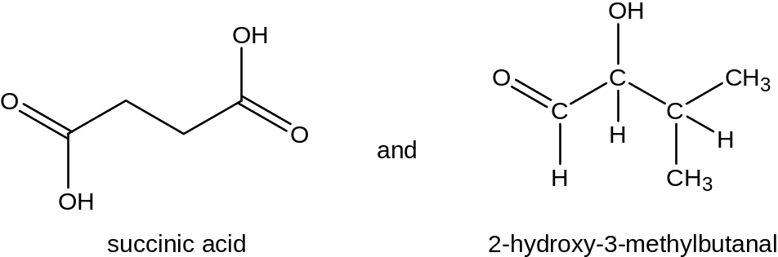
Reagent(s) : …………………………………………………….…………………

Conditions : …………………………………………………….…………………

 |  | Observations for succinic acid:
 |  | …………………………………………………………………………………………………
 |  | Observations for 2-hydroxy-3-methylbutanal:
 |  | …………………………………………………………………………………………………
 |  |  | [2]
 |  |  | [Total: 9]

4 | (a) | Phenolphthalein is one of the most common indicators used to determine the end point in a titration. When excess base is present at the end of an acid-base titration, the pink colour fades after the solution is left to stand in air for a while.  The structure of phenolphthalein is abbreviated as ‘Y’.  The fading of phenolphthalein in aqueous NaOH (above pH 10) can be studied to determine its rate equation. The concentration of phenolphthalein in solution can be followed by a spectrophotometer, which measures the concentration of Y²⁻ in terms of “Absorbance”. [Y²⁻] is taken to be directly proportional to the absorbance of the solution.  Fig. 4.1 shows the absorbance versus time graphs obtained for two different concentrations of NaOH, 0.200 mol dm⁻³ and 0.400 mol dm⁻³. In each case, only one drop of phenolphthalein was used.  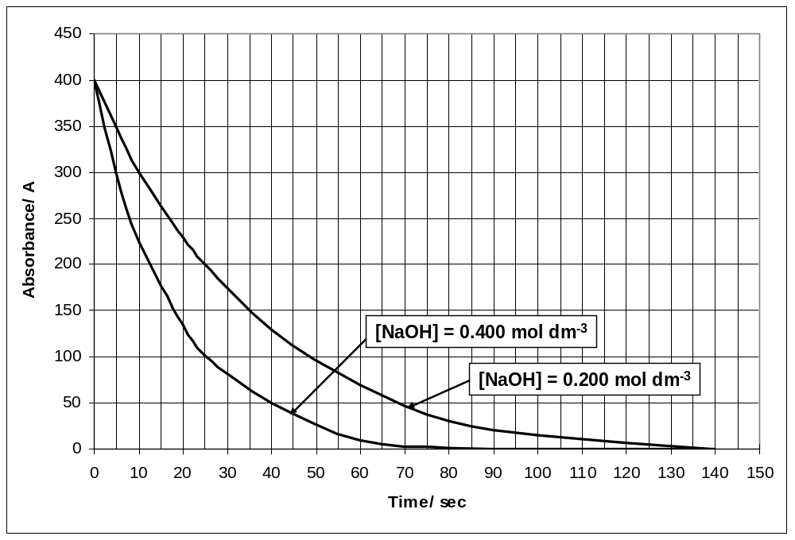  Fig. 4.1
  pH | Form of phenolphthalein | Colour
  Below 8 | H₂Y | Colourless
  8 to 10 | H₂Y + OH⁻ Y²⁻ + H₂O | Pink
  Above 10 | Y²⁻ + OH⁻ YOH³⁻ | Colourless
 |  |  | Use the graphs in Fig. 4.1 to find the order of reaction with respect to
 |  | (i) | NaOH;
 |  | (ii) | Y²⁻.
 |  | (iii) | Hence state the rate equation based on a(i) and a(ii).
 |  |  | …………………………………………………………………………………………....
 |  |  | [5]
 | (b) | Finland currently generates 55 % of its heat and energy from burning of fossil fuels which produces CO₂. This gives rise to increased CO₂ emission and poses environmental problems. However, CO₂ can be removed by reacting with MgO to form MgCO₃.
 |  | (i) | MgO is formed from the thermal decomposition of MgSiO₃, a major component in mineral rocks. In this process, SiO₂ is also produced. Write a balanced equation for the thermal decomposition of MgSiO₃.
 |  |  | …………………………………………………………………………………………...
 |  | (ii) | During the thermal decomposition of mineral rocks, impurities like SO₂ are also produced. Arrange MgO, SO₂ and SiO₂ in order of increasing acidity.
 |  |  | …………………………………………………………….……………………………..
 |  | (iii) | Suggest a method how MgO can be separated from a mixture of MgO, SO₂ and SiO₂. Write balanced equations for the reactions involved.
…………………………………………………………….……………………………..

…………………………………………………………….……………………………..

…………………………………………………………….……………………………..

…………………………………………………………….……………………………..

…………………………………………………………….……………………………..

…………………………………………………………….……………………………..
 |  |  | [5]
 |  |  | [Total: 10]

Section B
Answer two of the three questions in this section on separate writing papers.

Begin each answer on a fresh sheet of paper.

5 | (a) | Ethyl acetate or ethyl ethanoate is the organic compound with the formula CH₃COOCH₂CH₃. Ethyl acetate is the ester of ethanol and acetic acid; it is manufactured on a large scale for use as a solvent. It is formed according to the equation below.  CH₃COOH(l) + CH₃CH₂OH (l) CH₃COOCH₂CH₃(l) + H₂O(l)  In an experiment, 1 mol of ethanoic acid and 2 mol of ethanol were shaken for a long time to reach equilibrium. The whole mixture was titrated quickly with 80 cm³ of 2.00 mol dm⁻³ of sodium hydroxide.
 |  | (i) | Calculate the number of moles of ethanoic acid present at equilibrium.
 |  | (ii) | Calculate the number of moles of ethanoic acid that had reacted with ethanol.
 |  | (iii) | Calculate the number of moles of ethanol, ester and water present at equilibrium.
 |  | (iv) | Write an expression of the equilibrium constant, K_{c} for this system.
 |  | (v) | Calculate the value of the equilibrium constant, K_{c}.
 |  | (vi) | State the effect on K_{c} if 0.1 mol of ethanol liquid was introduced into the container after equilibrium has been established.
 |  |  | [7]
 | (b) | Ethanoic acid, CH₃COOH is a corrosive acid. Its vapour irritates the eyes, produces a burning sensation in the nose, and can lead to a sore throat and lung congestion.
 |  | (i) | Suggest the reagents and conditions for the conversion of ethanoic acid into an alcohol.
 |  | (ii) | Name the type of reaction that occurs and write a balanced equation for the conversion of ethanoic acid into an alcohol.
 |  | (iii) | Describe what you would observe when ethanoic acid was reacted with sodium metal.
 |  |  | [4]
 | (c) | Period 3 chlorides such as PCl₅, POCl₃, PSCl₃ and SiCl₄ have many uses.
 |  | (i) | Describe and explain what you would observe when water is gradually added to PCl₃, until in excess. Suggest the pH of the solution thus formed.
 |  | (ii) | Suggest a balanced equation with state symbols for the reaction of liquid silicon tetrachloride with heavy water, D₂O [deuterium, D= 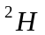].
 |  |  | [4]
K  Atomic No.  First Ionisation Energy  x x+1 x+2 x+3 x+4  J  L  M  N | (d) | The graphs below show the variation in first ionisation energy of some elements. Fig. 5.1 refers to successive elements in the same period, and Fig. 5.2 refers to successive elements in the same group as element J.  Fig. 5.1 Fig. 5.2  Atomic No.  First Ionisation Energy  x-8 x x+8  J
 |  | (i) | Given that element J is a Group II element. Copy the diagram below into your answer paper. Label clearly how the beams of J⁺ and K⁺ ions are deflected when subjected to an electric field.  You should relate clearly the magnitude and the direction of deflection of each beam to the other.  +  −  Source  [3
 |  | (ii) | State and explain which period element J is in and hence identify J.
 |  |  | [5]
 |  |  | [Total: 20]

 | 6 |  | Compound A, a derivative of Decalin is a colourless liquid. It can undergo the following 3-step reaction scheme.  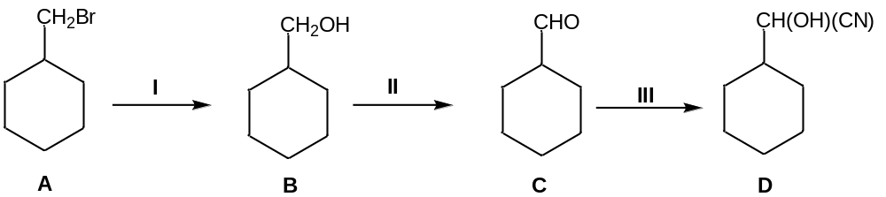
 |  |  | (a) |  | (i) |  | What reagents and conditions are needed for reactions I, II and III?
 |  |  |  |  | (ii) |  | Name the type of reaction for reaction III.
 |  |  |  |  | (iii) |  | Reaction II is an oxidation reaction. Write a balanced equation for reaction II (the symbol [O] is acceptable in this equation).
 |  |  |  |  |  |  | [5]
 |  |  | (b) |  | Draw the organic product formed when B is reacted separately with each of the reagents and conditions stated below.
 |  |  |  |  | (i) |  | Al₂O₃, 350°C;
 |  |  |  |  | (ii) |  | PCl₅.
 |  |  |  |  |  |  | [2]
 |  |  | (c) |  | (i) |  | Compound A, C₇H₁₃Br has a structural isomer with a straight chain and displays geometric isomerism. Suggest a possible structure of the isomer.
 |  |  |  |  | (ii) |  | Suggest a chemical test to distinguish A and the isomer identified in (c)(i). State the observations for the test.
 |  |  |  |  | [3]
 |  |  | (d) |  | Compound D with molecular formula C₉H₈O is used as a drug carrier. D is insoluble in sodium hydroxide but reacts with 1 mole of bromine gas in the dark to form E, C₉H₈OBr₂.  When E is heated with aqueous potassium hydroxide, F, C₉H₁₀O₃, a neutral compound is formed.  Treatment of D with Tollens’ reagent will yield silver mirror but when treated with Fehling’s solution, blue colour solution remains. When D is heated with acidified potassium manganate(VII), G, C₈H₆O₄, is formed. G will produce effervescence when Na₂CO₃ is added to it.  Use all of the above information to identify the organic compounds D, E, F, and G. Include the following in your answers.
 |  |  |  |  | (i) |  | Structural formula for each of the organic compounds.
 |  |  |  |  | (ii) |  | Clearly show all of the deductions that you make from the information that you have been given.
 |  |  |  |  | [10]
 |  |  |  |  | [Total: 20]
7 |  | Chromium is a very shiny, silvery metal whose Greek name, Chroma, refers to its many colourful compounds.
 |  | (a) |  | In air, chromium readily forms a thin and transparent coating of Cr₂O₃. Like Al₂O₃, Cr₂O₃ is an amphoteric oxide and can react with both acids and bases.
 |  |  |  | (i) |  | Suggest a reason why chromium is used extensively as a coating for other metals like iron.
 |  |  |  | (ii) |  | Write 2 balanced equations with state symbols that shows the amphoteric nature of Cr₂O₃.
 |  |  |  |  |  | [3]
 |  | (b) |  | Chromium can also exist in the form of chromate, CrO₄²⁻, which can be prepared from chromium(III) chloride. This conversion takes place in the presence of hydrogen peroxide, H₂O₂.
 |  |  |  | (i) |  | Write the half equation for the conversion of H₂O₂ to OH⁻ in alkaline medium.
 |  |  |  | (ii) |  | Given that the half equation for the conversion of Cr³⁺ to CrO₄²⁻ in alkaline medium is as shown below.  Cr³⁺(aq) + 8OH⁻(aq) CrO₄²⁻(aq) + 4H₂O(l) + 3e⁻  Using your answer to b(i), write the overall balanced equation of the conversion of Cr³⁺ to CrO₄²⁻ in the presence of H₂O₂ in alkaline medium.
 |  |  |  | (iii) |  | Hence calculate the minimum volume of 0.200 mol dm⁻³ H₂O₂ required to convert a sample of 0.500 g of CrCl₃ completely to CrO₄²⁻.
 |  |  |  |  |  | [5]
 |  | (c) |  | Draw the dot-and-cross diagram of H₂O₂ and state its shape.
 |  |  |  | [2]

 | (d) | Besides chromium(III) chloride, chlorides of Period 3 elements are also well-studied. State and explain the electrical conductivity of the chlorides of magnesium and phosphorous respectively in both molten and aqueous states.
 |  | [3]
 | (e) | The following diagram shows how the NH₃ molecules are arranged around the central Cr³⁺ ion in a [Cr(NH₃)₆]³⁺ complex.  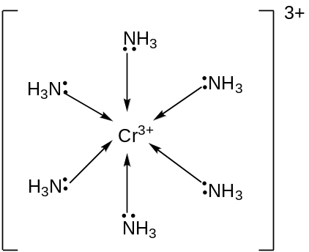  The arrow denotes a dative bond from the N atom to Cr³⁺, as shown below:  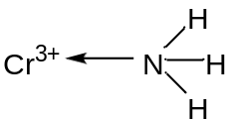
 |  | Using the Valence Shell Electron Pair Repulsion (VSEPR) Theory, explain the phenomenon that the H-N-H bond angle in ammonia when it is bound to Cr³⁺ is about 110 º, while that in an isolated ammonia molecule is about 107 º.
 |  | [2]
 | (f) | In another compound containing boron chloride and phosphine, an equilbrium exists between the compound, PH₃BCl₃, and its adducts PH₃ and BCl₃ as shown.  PH₃BCl₃(s) PH₃(g) + BCl₃(g) ∆H > 0
 |  | (i) | Write an expression for the equilibrium constant, K_{c}, for the decomposition of solid PH₃BCl₃.
 |  | (ii) | A solid sample of PH₃BCl₃ is introduced in a closed vessel and decomposes until equilibrium is established. Explain how the equilibrium position will be affected when the
- temperature is increased to 373 K.

- solid PH₃BCl₃ is added to the system at equilibrium.
 |  |  | [5]
 |  |  | [Total: 20]

